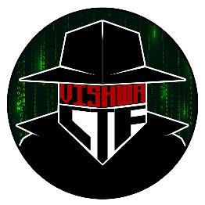

CHALLENGE NAME: [THE LECTURE CODE]   
DEV : [RIYA SHAH]

CATEGORY: [OSINT]   
LEVEL: [MEDIUM]

2025



CHALLENGE NAME: [THE LECTURE CODE]

**Challenge Description**:

A renowned computer science professor, known for his legendary lectures, once hinted at a hidden message buried within his online presence. Over the years, students speculated about a secret key—a passphrase that unlocks an unknown treasure of knowledge.

Recently, a rumor saying that cryptic message surfaced in an obscure GitHub repository was heard ,was it fake or really exists and reveals his secret after all? quack!

Flag format : VishwaCTF{}

**Solution:**

1. From the challenge description,we get to know that we're supposed to find a Computer Science Professor,also Quack is given.
2. These 2 hints direct us to Prof David J Malan of Harvard University.
3. If we go to his website davidjmalan.com or https://cs.harvard.edu/malan/ we find a series of his social accounts there.

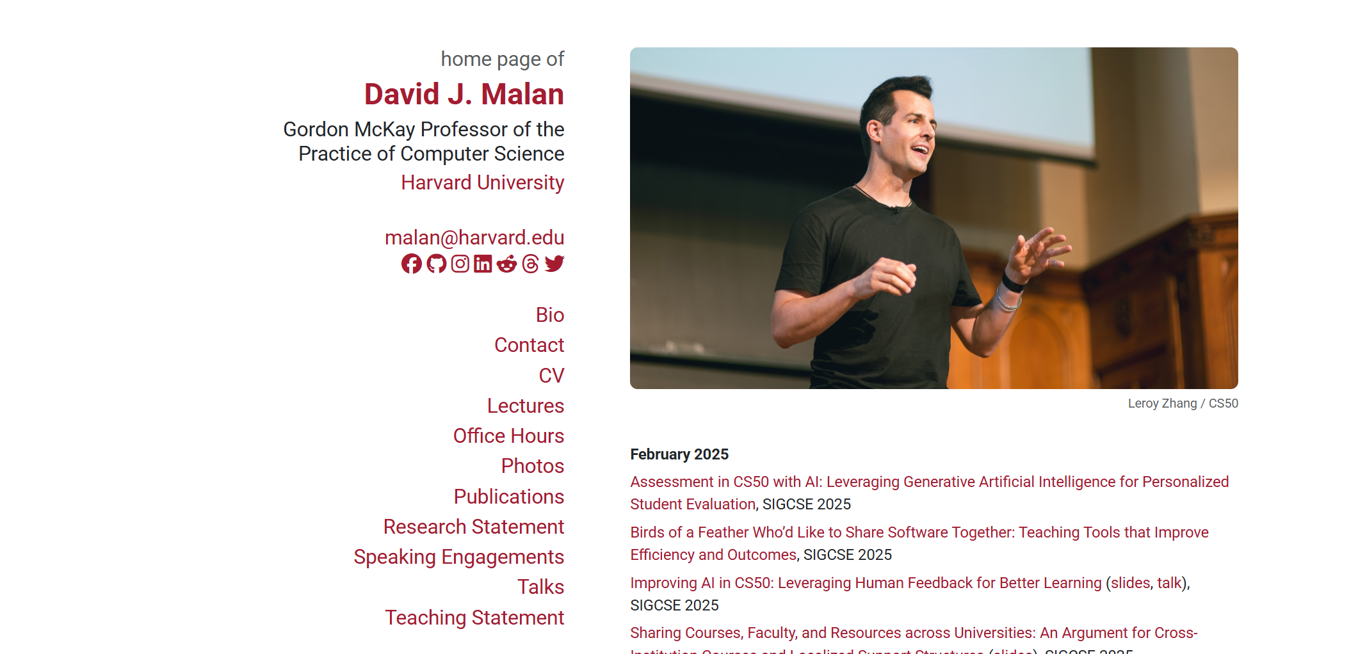

4) Since we're told about some Github repository in the description,we go to his Github Account.

5) Upon viewing,we see many of his repositories,of which we choose the CyberSecurity one(since a CTF Event,CyberSecurity Domain).

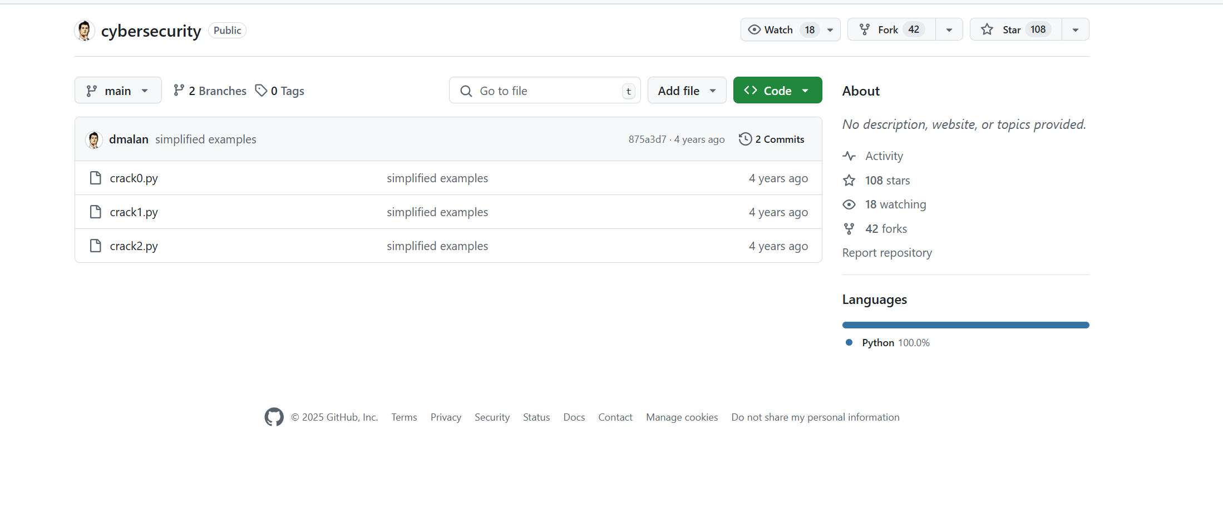



6) Nothing useful is found in the repository,so we check its forks once by https://github.com/dmalan/cybersecurity/network/members .The Challenge Author's name is found here,so we go to it.

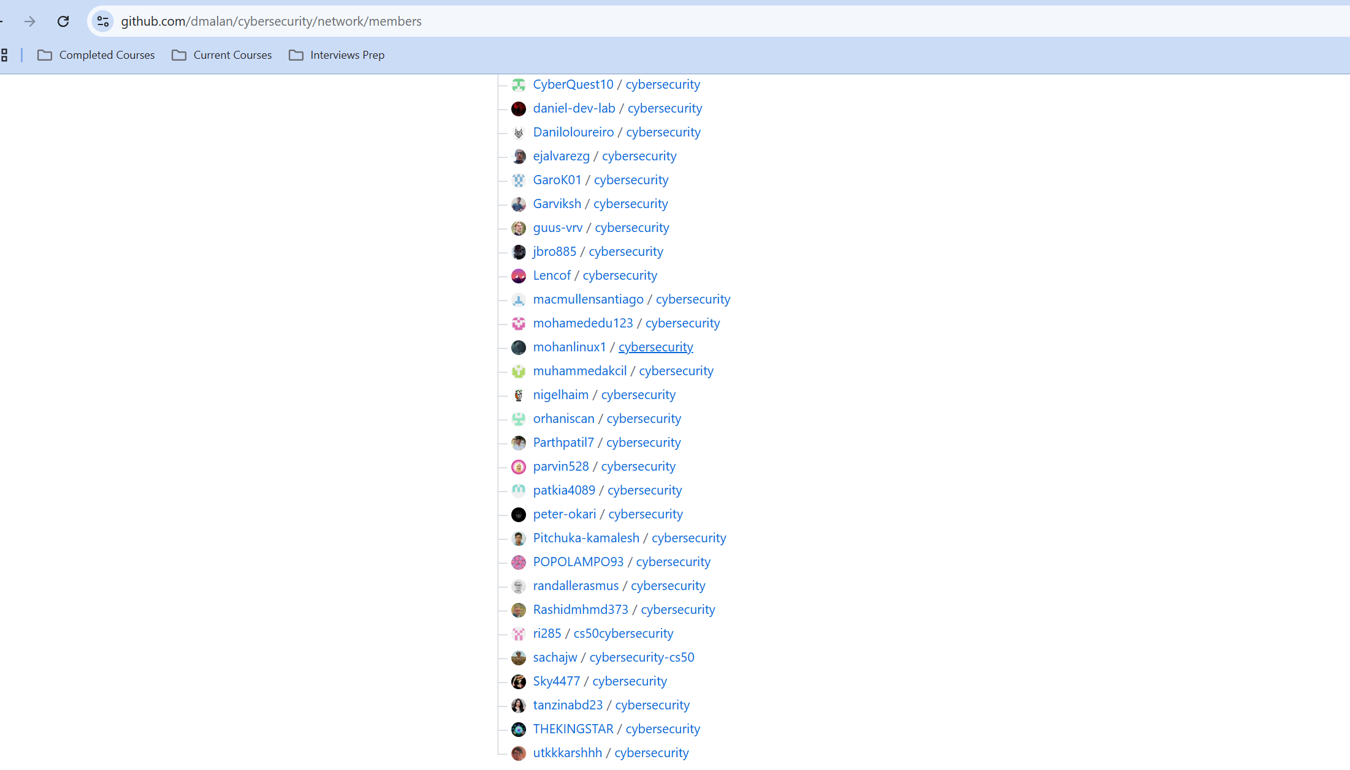

7) Three files are found,of which 3rd one seems some sort of decryption code,but no hidden passphase is found in it.

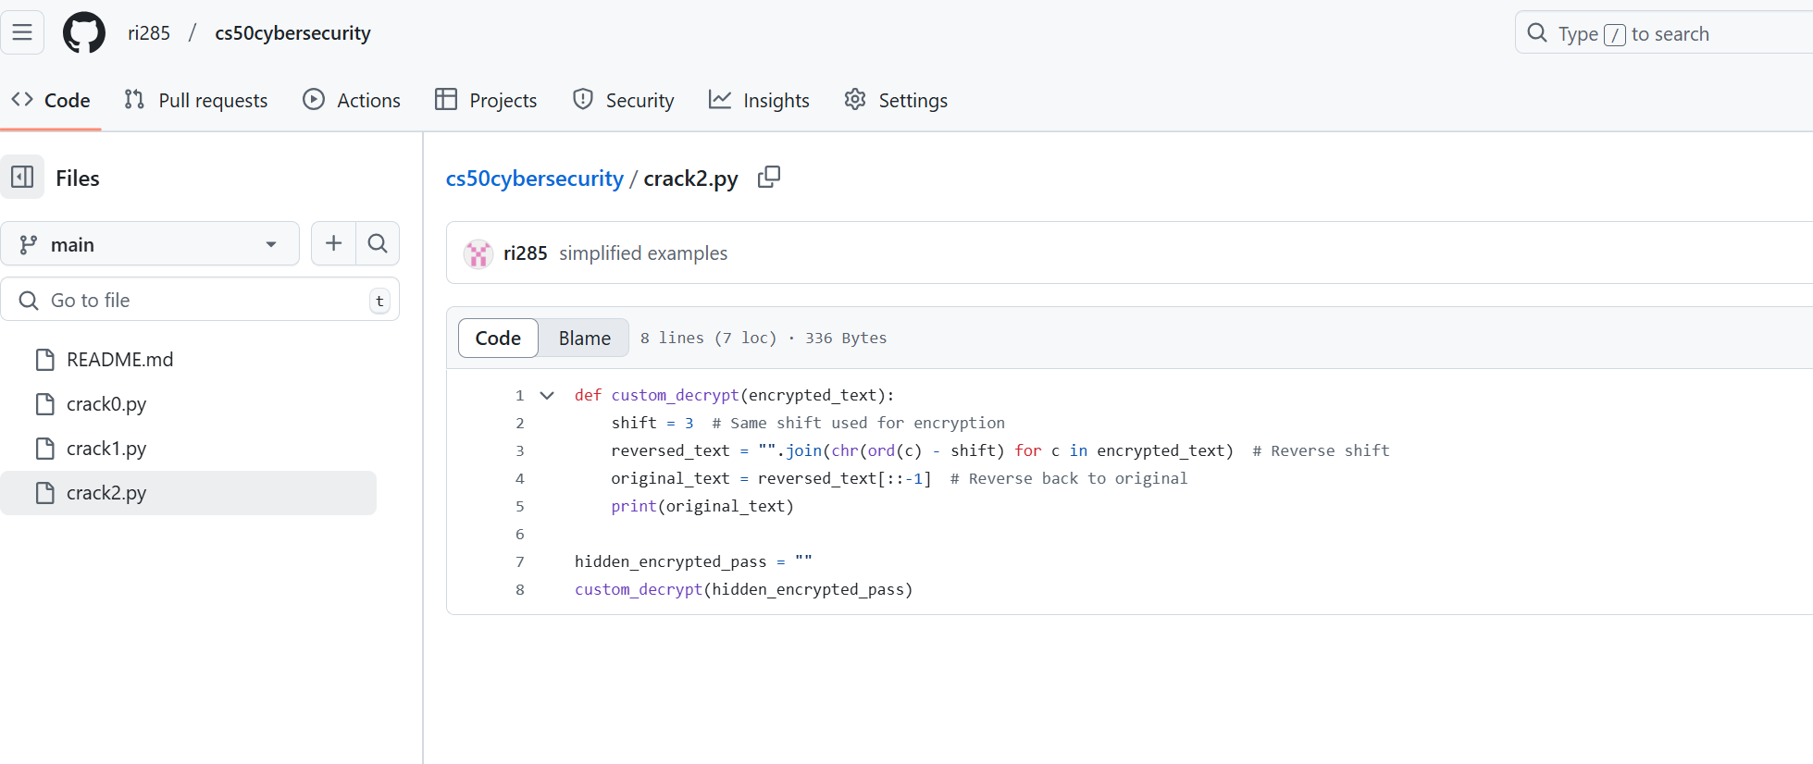

8) To find it,we go through his other social accounts.On Linkedin we find some cipered text in one of the comments on his post.

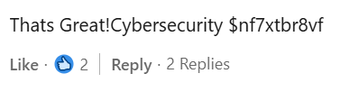

9) On using this as the hidden passphase,we get the flag.

**Flag: VishwaCTF{cs5o_qu4ck!}**

